|  |
| --- |
| genweb2 ltd. |
| Samuda HR Attendance User Manual |
| REFERENCE: GW/ERP/USER MANUAL |
|  |
| **Genweb2 Ltd.** |
| **09-May-17** |

|  |
| --- |
| logo.png  **Genweb2 Limited**  TK Bhaban (11th Floor),  13 KaziNazrul Islam Avenue,  Kawran Bazar, Dhaka 1215, Bangladesh  web: [http://www.genweb2.com](http://www.genweb2.com/) |

Contents

1. HR Attendance Management 3

1.1 Map to Attendance Device with Employee 4

1.2 Shifting 5

1.3 Assign Shifting for Each Employee 6

1.4 Attendance Device Configuration 6

1.5 Import Attendance 8

1.6 Attendance Summary 9

1.7 Alter Rostering 12

1.8 Correct Attendance 12

1.9 Manual Attendance 14

# 1. HR Attendance Management

One key ingredient to success in the workplace is to ensure that staff consistently attend work. As an administrator, we can positively and proactively encourage attendance by communicating with staff, keep records to identify trends or trouble spots, and promote health and wellness with company staff. Attendance module can management all staff attendance process of an organization.

**How to install this Module:**   
In order to make use of attendance management features, user needs to install attendance module respectively which can be located in local modules under settings menu.

The following features for efficient attendance management process:-

* Map To Attendance Device
* Shifting
* Attendance Device Configuration
* Import Attendance
* Attendance Summary
* Alter Rostering
* Correct Attendance

## 1.1 Map to Attendance Device with Employee

First we need to map each employee with attendance device account number.

Using the menu **Employee ‣ Create/Select Employee ‣ HR Settings ‣** **Map to Attendance Device.**

We need to configure the following:-

**AC NO:** An employee account id. It must be same with attendance device account id.

After entering all information click **Save**.

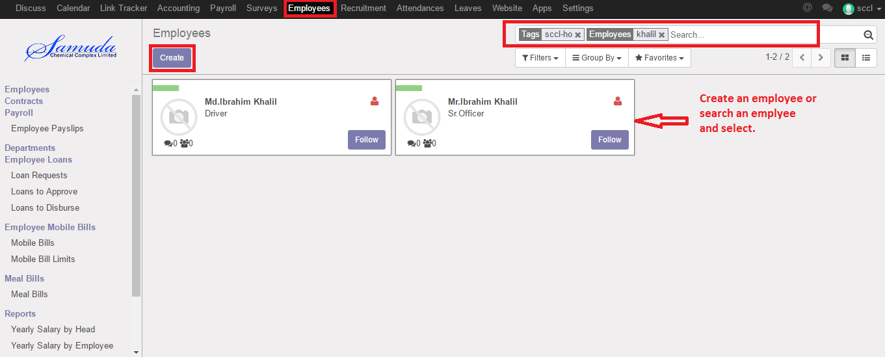

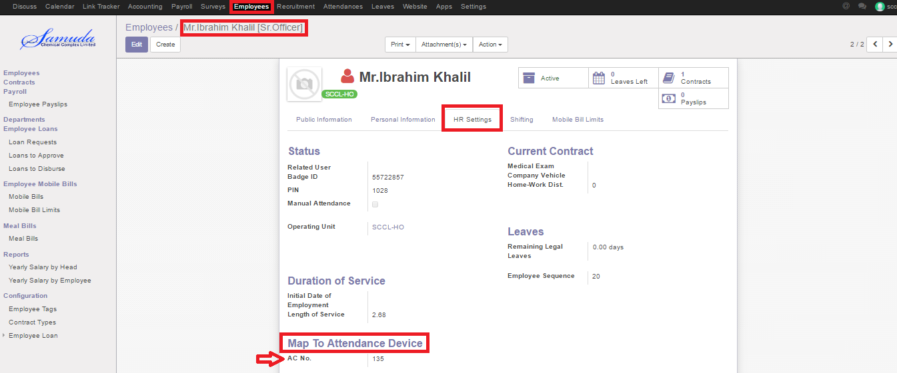

Figure: Map to Attendance Device with Employee

## 1.2 Shifting

Shift work is an employment practice designed to make use of, or provide service across, all 24 hours of the clock each day of the week (often abbreviated as 24/7). The practice typically sees the day divided into shifts, set periods of time during which different groups of workers perform their duties. We can create shifting by using the menu **Payroll ‣ Shifting** and click **Create.**

We can configure the following information:-

**Name:** A name for shifting.

**Workgroup Manager:** Select a user

**Day of Week:** A day name.

**Work From:** Starting time of work.

**Work To:** Closing time of work.

**OT From:** Starting over time of work.

**OT To:** Closing over time of work.

**Grace Time:** It is total break time of a day.

After entering the shifting information click **Save**.

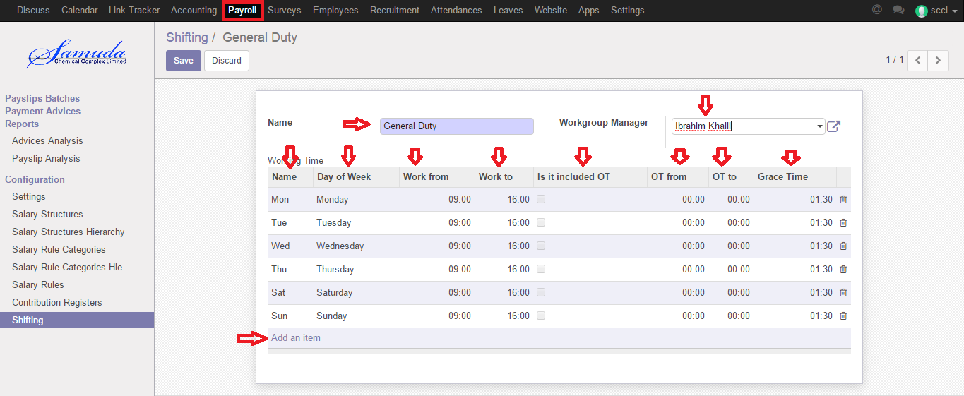

Figure: Shifting

## 1.3 Assign Shifting for Each Employee

We have to assign shifting for each employee what they must be follow.

We can assign shifting for each employee using the menu **Employee ‣ Create/Select Employee ‣ Shifting** and click **Create**.

We can configure the following information:-

**Shift Name:** Select a shift name.

**Effective Date:** Starting date to follow that assign shift.

**Effective End Date:** Closing date to follow that assign shift.

After entering the shifting information click **Save**.

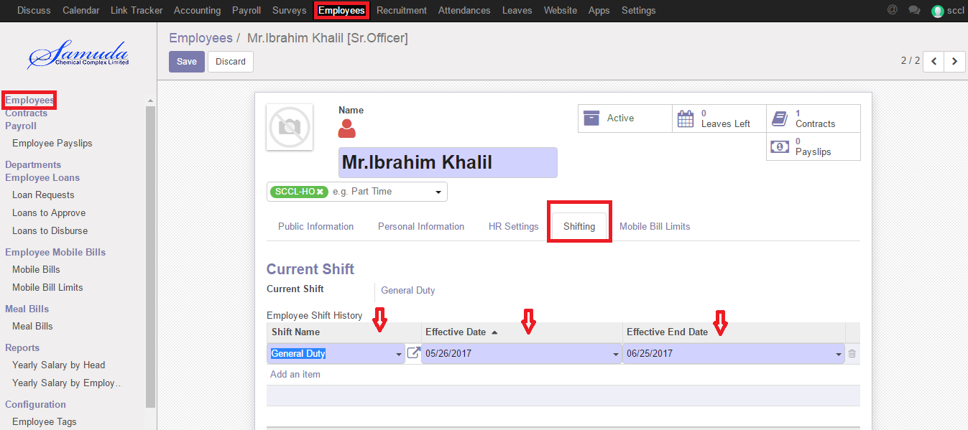

Figure: Map Shifting with Employee

## 1.4 Attendance Device Configuration

To get all attendance data from attendance device, we must configure attendance device with software and server.

We can create attendance device configuration using the menu**Attendances ‣ Device Configuration** and click **Create**.

We can configure the following information:-

**Location Name:** A location name.

**Connection Type:** Select a connection type.

**Server Address:** A server address.

**Database name:** A database name.

**Machine Number:** An attendance device machine number

**Pull:** By click pull button, we can get all attendance data.

**Test Connection:** By click test connection button, we can check connection.

After entering all information click **Save**.

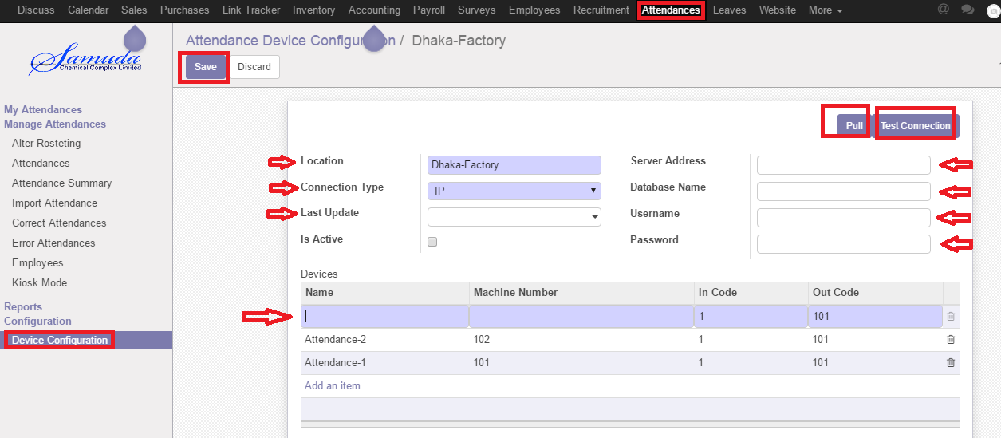

Figure: Attendance Device Configuration

After pulling all data, we can find all in attendance menu. **Attendances ‣ Attendance**

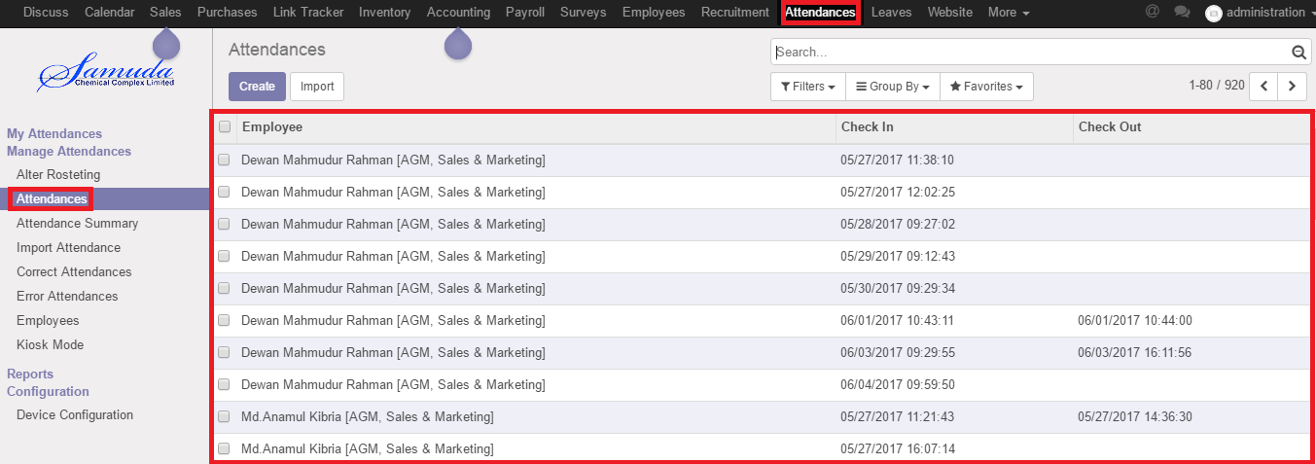

Figure: Create Attendance

## 1.5 Import Attendance

By creating import attendance, we can manually import employee attendance CSV file.

We can import attendance csv file using the menu**Attendances ‣ Import Attendance** and click **Create**.

We can configure the following information:-

**Name:** A name for Import attendance.

**Imported Date:** A date when you want to import.

**Browse:** Click browse button and import your csv attendance file.

After entering all information click **Save.**

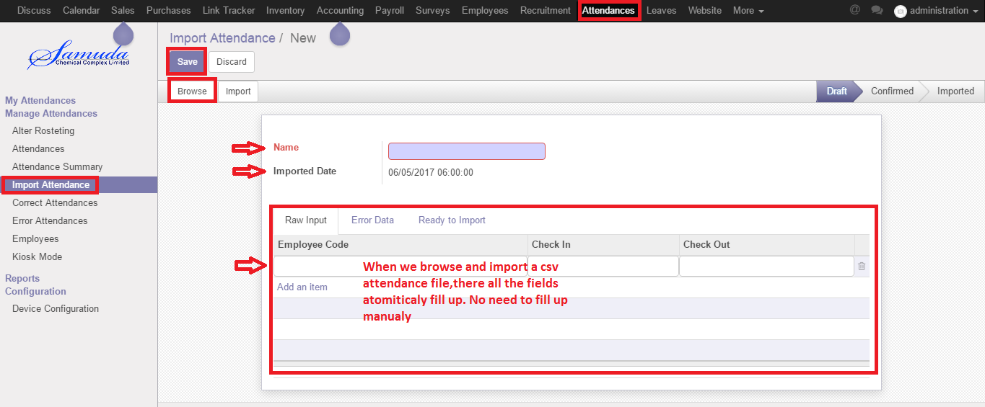

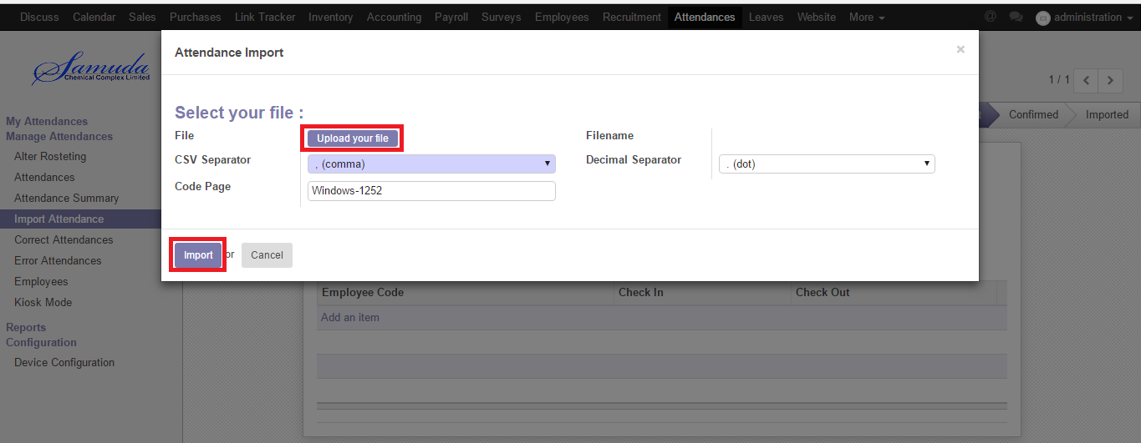

Figure: Import Attendance

## 1.6 Attendance Summary

The Attendance Summary report provides a details of all employee or individual employee. The system presents us all these reports automatically calculate and display overtime work hours as defined in overtime rules window. This same report can also be printed out in detail format. This will show us the actual checkpoint activity records that were recorded for the employee.

We can create attendance summary by using the **Attendances ‣ Attendance Summary** and click **Create**.

We can configure the following information:-

**Name:** A name for attendance summary.

**Period:** Select a period.

After entering all information click **Save.**

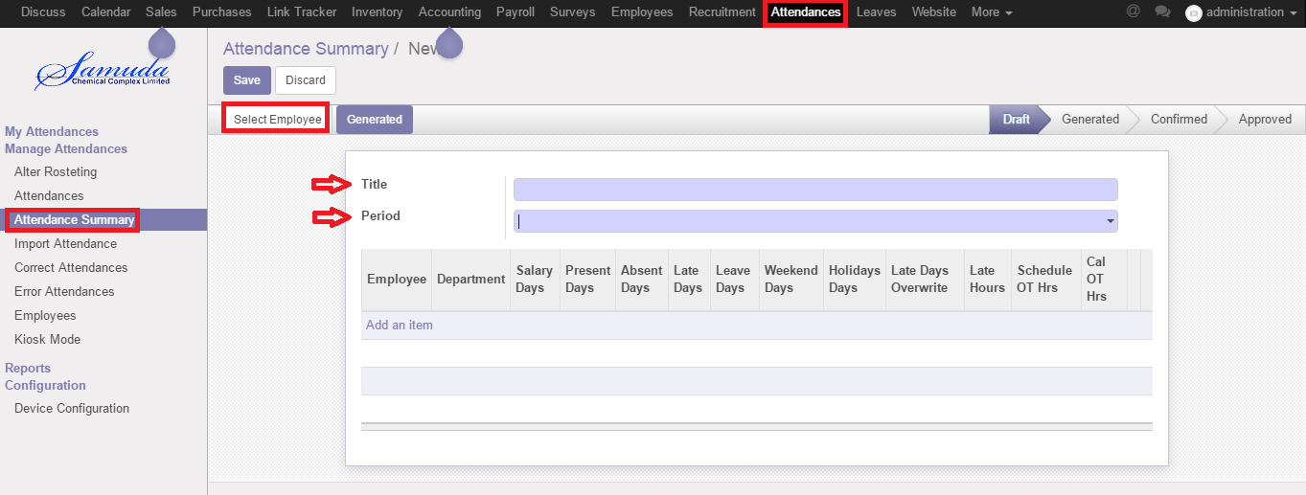

­­­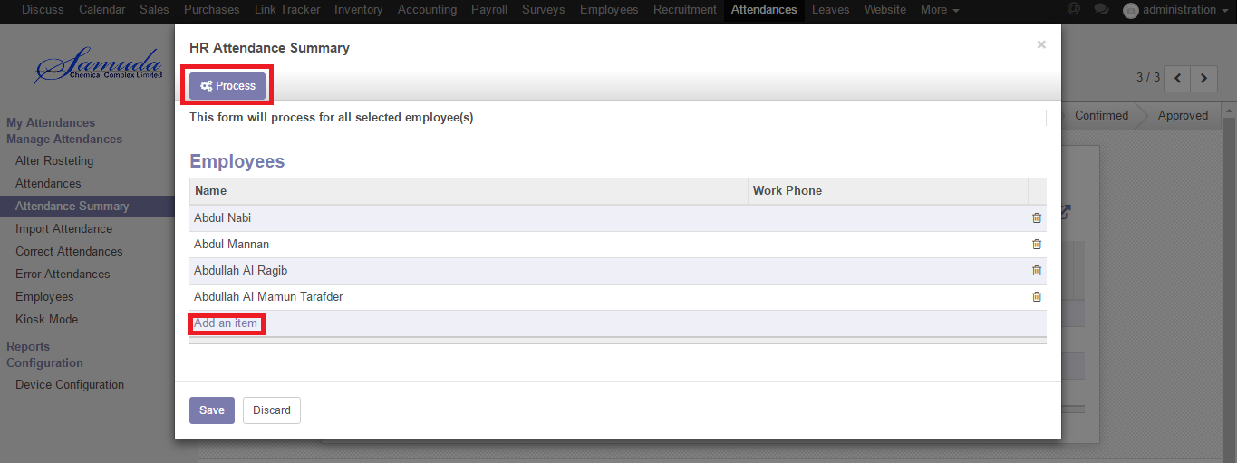

After processing we will show this window.

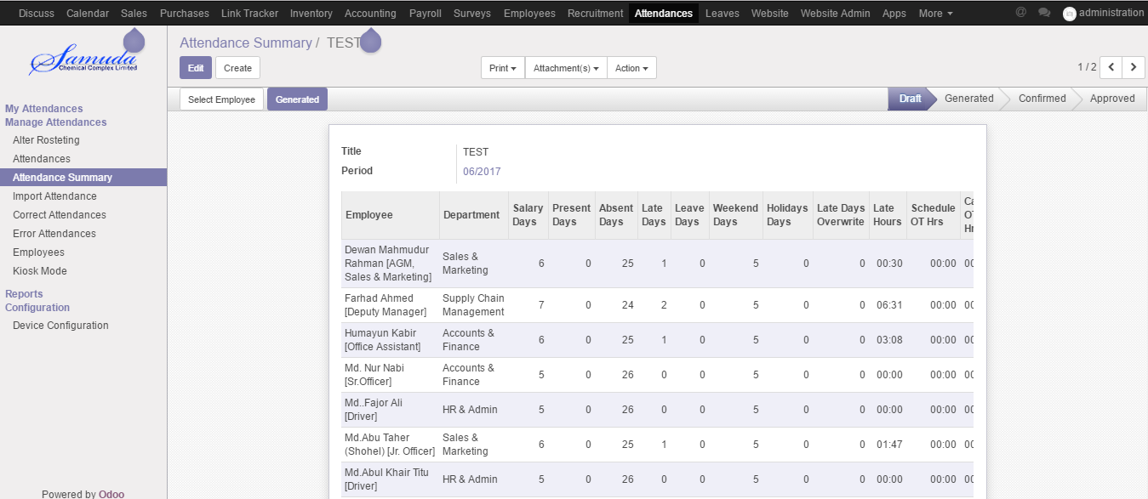

From this window we can select a employee and we can see his/her all absence day / late day/weeken day details.

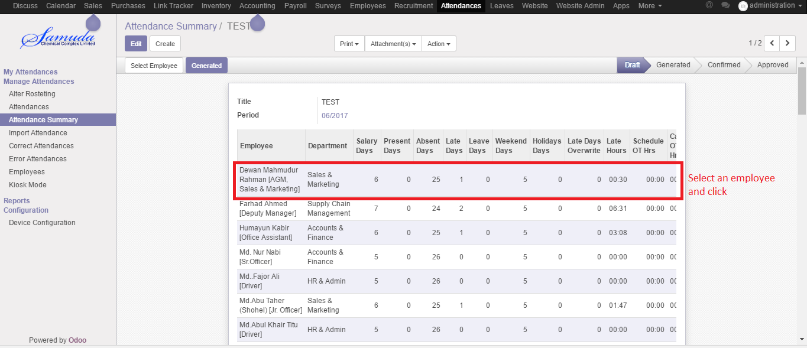

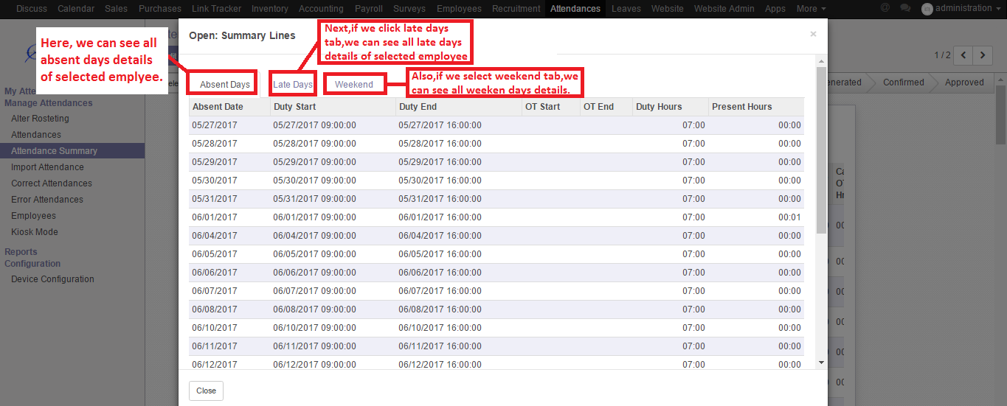

We can see more absent deatails by clicking each absent day as example, that day how many time that emplyee check in and check out.

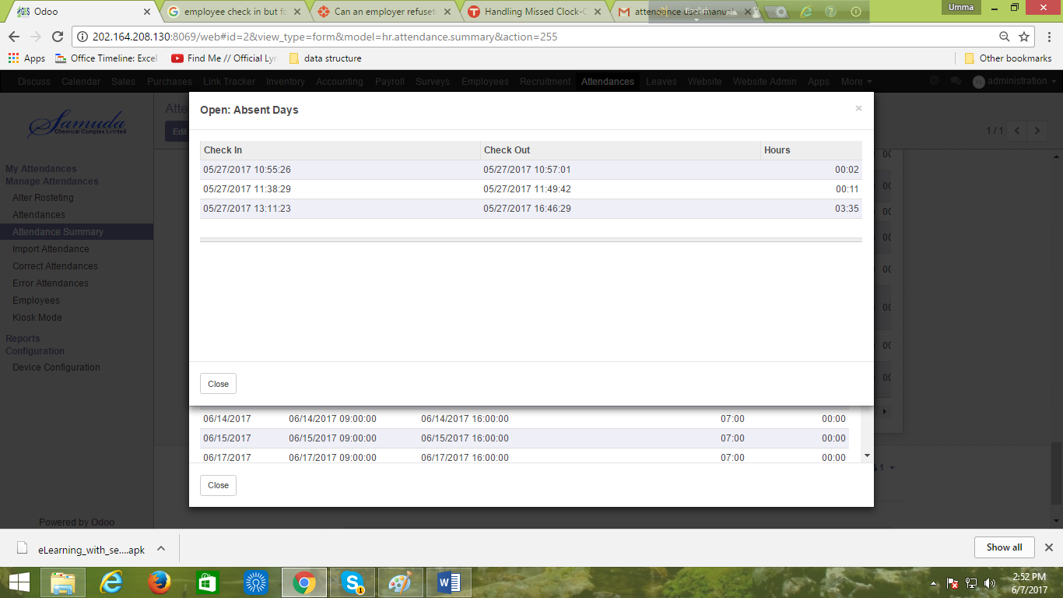

We can see more absent deatails by clicking each late day as example, that day how many time that emplyee check in and check out.

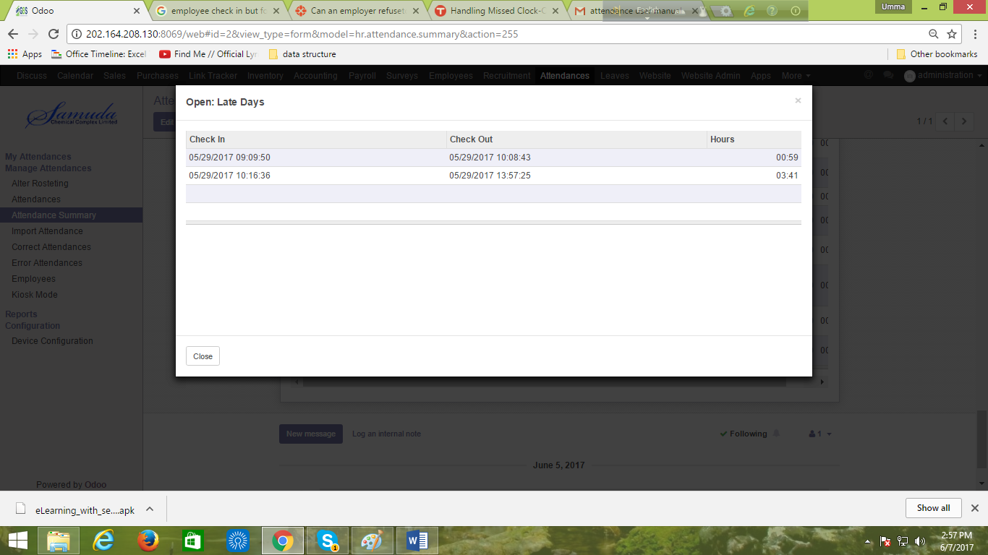

Figure: Attendance Summary

## 1.7 Alter Rostering

Sometimes employees want to change his/her shifting and they want to request manager. For solving this problem employee can request to manager by this alter shifting process.

We can create alter rostering using the menu **Attendances ‣ Alter Shifting** and click **Create.**

You need to configure the following:-

**Employee**: An employee name.

**Alter Date:** A date for attendance.

**Duty Start:** A work stating time.

**Duty End:** A work closing time.

After entering the alter rostering information click **Save**.

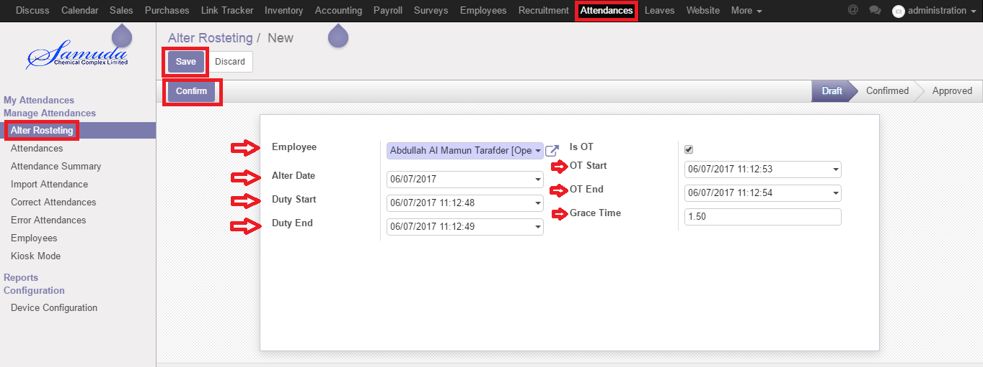

Figure: Correct Attendance

## 1.8 Correct Attendance

It is every staff responsibility to check in and out during every shift. They will receive compensation/wages only for the hours worked based on the time clock but when employees forget to check-out/check-in they have little recourse except to talk with a manager and let them know of their mistake by using alter shifting process. Then the manager has to manually adjust the employee’s timesheet by this correct attendance process.

We can create correct attendance using the menu **Attendances ‣ Correct Attendances** and click **Create.**

We need to configure the following:-

**Type**: Select a type like employee wise or department wise

**From Date:** A starting date.

**To Date:** A closing date.

After entering the correct attendance information click **Save**.

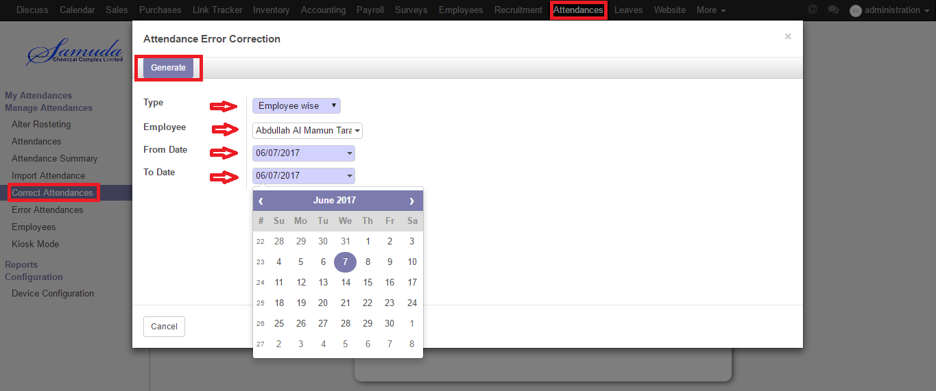

After click genarate button, we will see all error data between given period then we can error corecton manually.

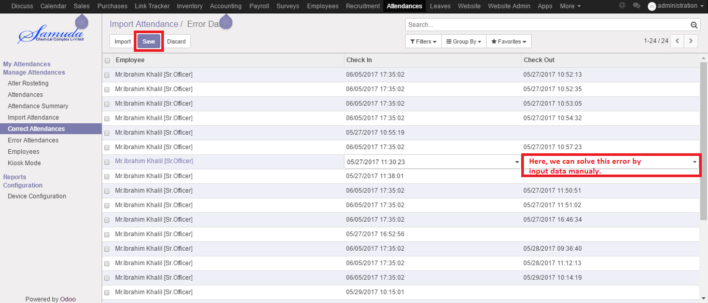

Figure: Correct Attendance

## 1.9 Manual Attendance

Sometimes employees work outside of office for this reason he/her can’t sign in or sign out. To solve this problem employee can request to manager by this manual attendance process.

We can create manual attendance using the menu **Attendances ‣ Manual Attendance** and click **Create.**

We need to configure the following:-

**Employee**: An employee name.

**Department**: Select a department.

**Sign Type:** Select a sign type.

**Check In:** Work starting time.

**Check Out:** Work closing time.

After entering all information click **Save**.

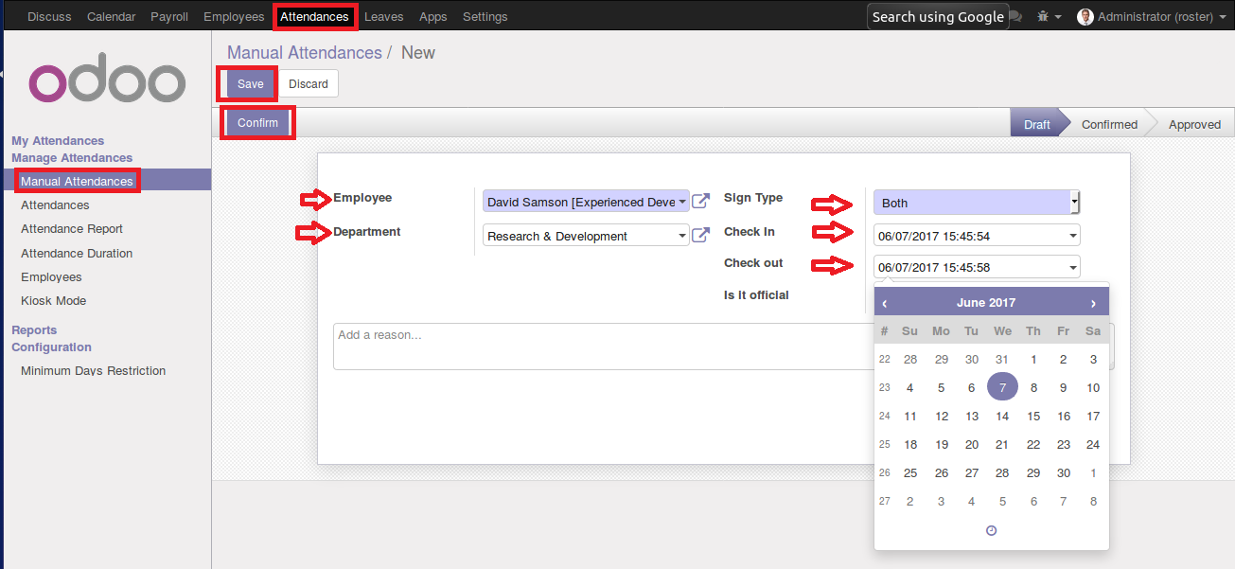

Figure: Manual Attendance